**Assignment 5.3.2**

**Mapreduce program to find the number of ratings given by each user.**

**Sample input:**

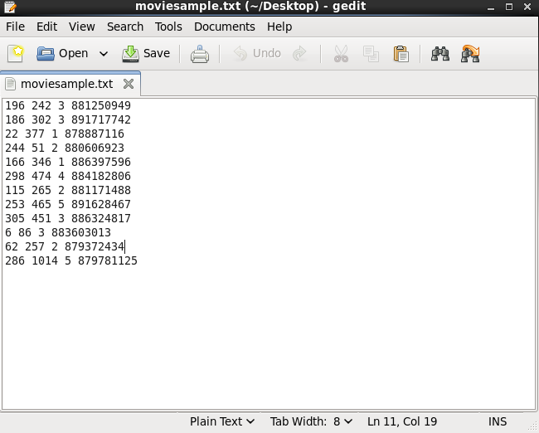

**Driver class:**

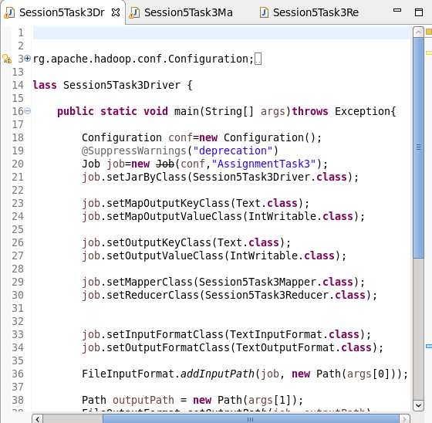

**Mapper class:**

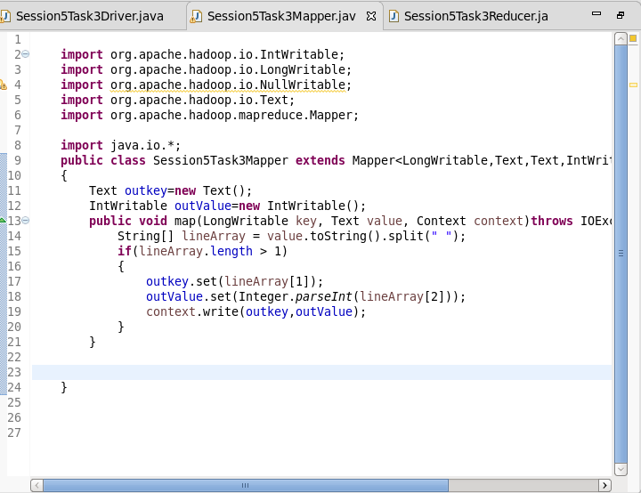

**Reducer class:**

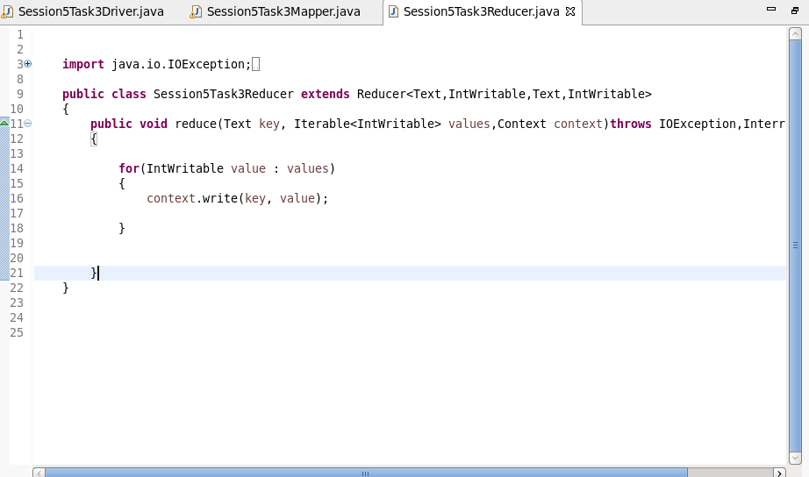

**Output:**

